CVHA
Recruitment

Pack
Maintenance &
Compliance
Manager

RECRUITMENT PACK

CONTENTS

Welcome Letter from the Chief Executive

About Clyde Valley Group

Clyde Valley Group Structure and Department structure chart

Role Profile and Person Specification

Your application

Application guidance notes

Key terms and conditions

WELCOME FROM THE CHIEF EXECUTIVE

Dear Candidate

Thank you for taking an interest in the role of Maintenance and Compliance Manager at Clyde Valley Group.

We appreciate that the Covid 19 pandemic is presenting a significant range of challenges and change for everyone. CVG is continuing in its commitment to support our team and customers through this difficult time and to be even more flexible and adept in how we work and in how we deliver services and review our priorities. I’m proud to say that we’re handling this situation, as ever, with compassion, mutual support and professionalism.

Our Maintenance and Compliance Manager role is one of our critical posts. Over the next 5 years, our asset base will grow to c£369m (net of depreciation) and we will be spending around £5.5m per annum on reactive repairs and planned and cyclical maintenance.

The Group has successfully established our reputation for building high quality new affordable homes for 24 years for social rent, mid-market rent and market sale. Over the last 10 years, we have invested £185m in Government housing grant and private finance from our lenders in new homes and have become one of Scotland’s top ten biggest developing Registered Social Landlords. Our current plans mean we aim to provide over 600 new homes by 2022, mainly for social rent.

Clyde Valley Housing Association is a Registered Social Landlord and a charity. We want to achieve the right balance of investing in new and existing homes and services with offering our customers great value for money at a price they can reasonably afford. We recognise the pressures our customers face. As we continue to grow, we are setting ourselves the challenge of keeping our costs down, increasing how efficient we are and driving up productivity. We will build on our strong foundations in governance to manage the risks whilst strengthening our skills in managing and harnessing change.

Much is changing for our customers and for the housing sector and Scottish Government is encouraging us all to think as far ahead as 2040. There are huge challenges of achieving a carbon neutral Scotland, addressing poverty and inequality, growing numbers of older people and single households, health needs, homelessness, welfare benefit changes and the rapid development of new technology in all areas of life. We’ll be doing more work on the future design of our new and existing homes to support people throughout life changes.

Ambition and a focus to deliver better drives us on a daily basis and we intend to ensure our customers experience excellent service and influence what we do, in ways that make them feel valued and understood. Over the next 2 years, our service will look and feel more responsive, modern and flexible as we use customer insight and data to drive decisions and improvements. There will be more opportunities to access services 24/7 on line and we will continue to test and drive up the quality of our customer service and performance, including through Customer Services Excellence Accreditation.

If you’re successful, I’m confident that you’ll receive the warmest of welcomes and you’ll feel valued as part of an exceptional team. We’re a team that chooses to be positive. Getting the right work/life balance for our people is a must and we’re delighted to have achieved Healthy Working Lives Gold in 2020.

Clyde Valley Housing Association wants every member of its team to realise their potential, so we can meet future challenges, spot new opportunities and deliver something exceptional for customers.

We look forward to receiving your application and best of luck!

Lynn Wassell

Lynn Wassell
Chief Executive
Clyde Valley Group

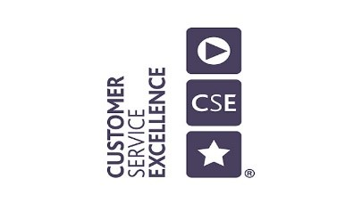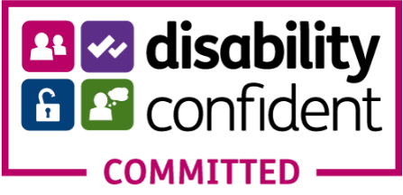
ABOUT CLYDE VALLEY GROUP

Who We Are
CVHA is a Registered Social Landlord (RSL) partner in Lanarkshire and East Dunbartonshire, Our Group continues to grow and we now own around 4200 homes and provide factored services to more than 3000 owners. We are proud that people see us very much as a local and regional landlord and employer. We make a notable difference to lives and communities, including to help meet housing needs. By 2025, we’ll be providing a brilliant customer experience to at least 8500 customers.

Our Vision
To provide high quality homes and services that make a difference to people’s lives and their communities

Our Values
BE all about the customer
Customers are our first priority and they drive everything we do and how we do it. This means we will make sure we know our customers well, do the right thing, and always deliver on our promises.
BE ambitious
CVG and our people continue to grow and we’ll always be ready for any opportunity as long as it benefits our customers. We’ll support customers to realise their ambitions too.
BE driven by excellence
Our CVG team is relentless about doing better for customer, learning and focussed on improving performance, doing more for customers and reducing customer effort.
BE caring
Most importantly we’re people centred, will listen and support customers and eah other. We care about getting it right for customers

*To view our corporate strategies and supporting case studies click here
*To view our short films made click here

CLYDE VALLEY GROUP STRUCTURE

PROPERTY & DEVELOPMENT STRUCTURE

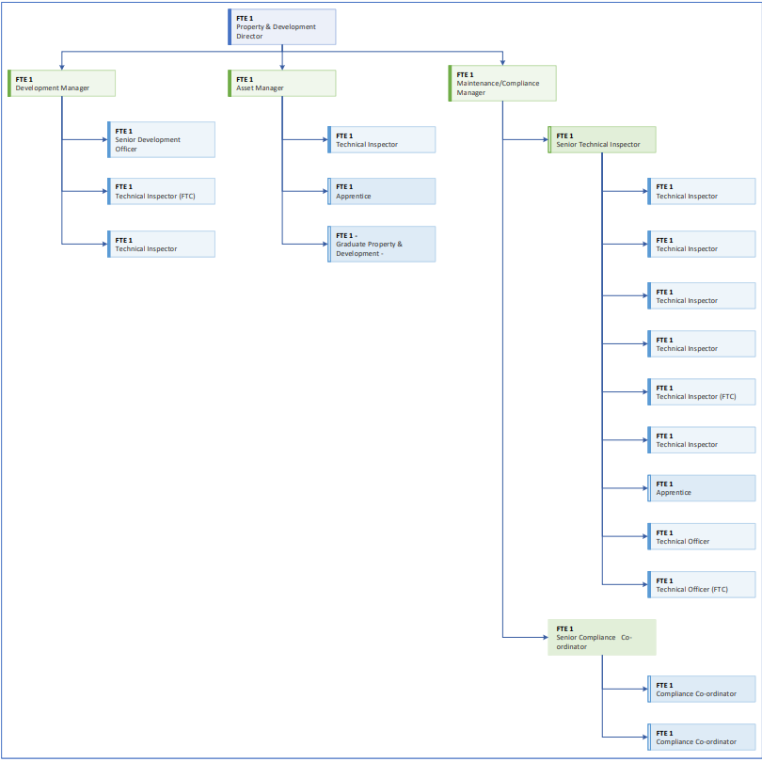

ROLE PROFILE

Job Title: Property Maintenance & Compliance Manager

Salary: Competitive

Responsible for: Maintenance and Repairs Team – Technical and Compliance

Reporting to: Property and Development Director
Overall Purpose:
- Responsible for the development and delivery of an integrated and consistent reactive, void, and cyclical repairs and maintenance service provision across all tenures, considering external best practice, regulatory requirements, and business priorities.

- Apply strategic thinking to optimising asset value, value for money and customer satisfaction in consideration of service modernisation, preventative, void, and reactive maintenance strategies.

- Responsible for the provision of an excellent repairs service to all the Association’s customers, both internal and external.

- Ensure the association meets all its statutory and regulatory obligations in relation to compliance within the field of property maintenance.

Key Accountabilities:
Property & Repairs Service

- Ensure the Maintenance and Repairs team delivers of an excellent frontline maintenance and repairs service.

- Lead and be responsible for ensuring Clyde Valley Housing Group meets all statutory and regulatory compliance in the maintenance, repair and improvement of its properties, and the properties it maintains for others, across all tenures.

- Devise, implement, and deliver void, cyclical, planned preventative, and reactive maintenance and repairs service plans which deliver statutory and regulatory compliance and best value.

- Lead on the procurement of contracts and contractors in accordance with Procurement Procedure establishing value for money whilst ensuring quality is maintained.

- Responsible for the monitoring and scrutiny of maintenance and repairs contractors ensuring all contract terms and targets are met in accordance with timescales, rate schedules, quality and performance, and customer satisfaction.

- Analyse maintenance and repairs data to advise on component life cycle, common component failure, component quality, typical and common repairs, and average repair costs.

- Lead on the establishment, and on-going development, of a robust programme for periodic inspections of properties to ensure aspects around welfare, safety and regulatory compliance are met.

- To provide effective leadership to the Technical Team and the Contract and Compliance Team in all aspects relating to the delivery of the maintenance and repairs service, ensuring value for money and service excellence is understood and embedded across the service.

- To manage, motivate, mentor, and support all maintenance and repairs service colleagues, including defining, reviewing, evaluating, and improving team performance in line with both service, and organisational targets.

- Work closely with the Development Manager and Asset Manager providing technical support and contributing to the 30-year investment plan and Asset Management Strategy.

- Lead in the review and monitoring of all appointed contractors to ensure they meet the needs of the current and future reactive and planned maintenance works.

- Attend contractor performance meetings as a representative of the Property Service Directorate and CVHG.

- Lead and direct team colleagues on customer engagement and resolutions in respect of work orders, insurance claims, complaints, and contractor performance.

- Display a team approach to the delivery of all repairs’ services ensuring collaboration within the Property Directorate and other service areas within Clyde Valley Group.
Leadership and People Management
- Provide positive and effective leadership of the Team on a day-to-day basis
- Responsible for ongoing reviews of direct reports, to recognise coaching and training need and to promote staff development
- Deliver appropriate training within team/department required to support service delivery
- Fully engage your team in the Clyde Valley Group annual appraisal process, ensuring clear goals and objectives are set and tracked and that all team members have a personal development plan in place
- Actively support, promote, and celebrate successes.
- As line manager, ensure performance management, personal development and succession plans are in place for all employees and where possible, opportunities for career development and progression are made available
- Ensure effective application of all Clyde Valley Group HR Policies within your team
- Promote health, safety and wellbeing activities which encourage and support work/life balance
- Carry out all Management duties effectively including financial budgets, Health & Safety standards, Equalities, Performance Management and Risk Management, ensuring that the highest standards of governance, regulation and compliance are upheld and adherence to all relevant policies and procedures.

Partnership Working
- Develop excellent customer relationships and work with colleagues across the group to deliver an innovative and pro-active customer service.
- Participate in meetings with customer groups and various external agencies as required
- Attend other meetings as required.

Service and Performance Management
- Set, produce, analyse and review targets and Key Performance Indicators as required
- Review and monitor adherence to Property & Repairs Service Standards
- Co-ordinate a partnership working approach with colleagues and teams to improve services to customers
- Responsible for the organisation and delivery of projects under the direction of the Property Director
- Support the development of Repairs and Maintenance systems through generating development ideas, system testing, deployment, training and review. Actively promote best practice in use of systems with team and other colleagues throughout the wider business to enable a more streamlined service to all customers.
- Support the Business Improvement Team with the development and testing of systems and relay relevant information and updates to team members.

Compliance and Other
- Ensure compliance with all legislative and regulatory returns for your service areas, reviewing policies and procedures as required for your services.
- Provide timely and accurate Management Information for the purposes of reporting performance against our KPIs and Service standards.
- Prepare and submit data and information for our Annual Return on the Charter and other relevant regulatory requirements.
- Manage, monitor, and review the maintenance and repairs budget ensuring value for money and excellent customer service are achieved.
- Represent the Association as required at residents’ meetings, external events, committees/Board and other events, e.g. tribunals, appeals, court, etc
- Represent the Association at local housing strategy meetings, benchmarking working groups and other relevant working groups/forums.
- Lead in the development, review and revision of policies and procedures as they relate to the provision of CVG property maintenance and repairs.
- Provide regular reports on service provision as they relate to overall contractor performance, finance, compliance, and service plan performance targets and standards
- Undertake other reasonable duties as may be required.

The job description is intended to provide an outline of the post of Property Maintenance & Compliance Manager. The roles and responsibilities may alter due to changes in service delivery requirements, legislative changes, new technology or other external factors and thus, you may be required to carry out additional duties as allocated by the Property Director.

PERSON SPECIFICATION

 | Essential | Desirable
Qualifications | - Educated to degree level or other relevant qualification and equivalent relevant work experience. | - HND or higher in Building Surveying or other construction management discipline.  - A relevant professional membership.
Experience | - Proven track record, and experience in contract management and direct monitoring of contractors.  - A track record of leading, managing, and motivating successful teams to deliver excellent service provision and customer satisfaction.  - Experience of managing a responsive repair service with a focus on a “right first time” approach.  - Experience of managing property maintenance, compliance, and void repair programmes.  - Experience of budget planning and budgetary control, and management.  - Experience of meeting challenging targets and deadlines.  - Experience of managing corporate Health and Safety standards, and a working knowledge CDM 2015 regulations. | - Experience at a senior level within a social housing, or similar, repairs environment.  - Experience of effective partnership working with colleagues and other agencies.  - Experience of resolving customer complaints.  - Experience of dealing with challenging and vulnerable groups.
Knowledge/ Understanding | - A working knowledge of building standards and technical specifications.  - A working knowledge of Risk Assessments and Method Statements in Repairs and Maintenance.  - A working knowledge of Asbestos, Gas safety, and Fire Safety Regulations Scotland  - A good understanding of current procurement processes and regulations.  - Sound knowledge of relevant performance standards, good practice, regulation, and key performance indicators. | - Conversant with HR policies and procedures.  - Understanding of issues surrounding Social Housing.  - Working knowledge of relevant procurement legislation and regulation.
Skills | - Excellent interpersonal and communication skills (verbal and written) in establishing and maintaining working relationships and teambuilding.  - Strong organisational and time management skills.  - Ability to robustly monitor performance and value for money.  - Ability to communicate technical and compliance matters to non-technical colleagues, in a way which they understand and meet health and safety obligations  - Sound project management skills.  - Skilled in producing accurate and comprehensive management reports and review and drafting of policy and procedural documents.  - Effective in complaint investigation and resolution  - Excellence in the use of computerised systems.  - A basic level of competence in the use of Microsoft packages –including Office 365, Sharepoint, One Drive, Excel, and Word. | - Applying clear strategic thinking to decision making in key business areas.  - Ability to devise quality control systems and procedures.  - Use of Housing Management systems and reporting e.g.Capita.
People Leadership | - Ability to create and promote a team culture.  - Courage to tackle performance issues.  - Ability to motivate, develop and get the very best out of teams.  - Inspires teams to connect with our customers.
Personal Qualities | - Customer and outcome focussed.  - Drive, determination, and personal resilience.  - A passion for excellence.  - Personal integrity and confidentiality.  - Commitment to service excellence and continuous improvement.  - Strong commitment to the ethos and values of Clyde Valley Group and the social housing sector, including principles of involvement, equality, and social justice.  - Supports and develops others to realise their potential.  - Ability to follow policies and procedures and adapt to changes in working practices.  - Commitment to CVHA’s ethos and organisational values.  - Ability to promote equality and diversity.  - Self-motivated with ability to work on own initiative and committed to continuous improvement.
Other | - Ability to work flexibly.  - Current driving licence and access to a car for business purposes.

YOUR APPLICATION

Enquiries

For a confidential discussion please contact Nigel Fortnum or Mike Orr at our recruitment partners, Aspen People on 0141 212 7555.

In order to apply please send us:
- A comprehensive up-to-date CV which shows your full career history;
- A supporting statement explaining why you are interested in this role and how you match the person specification placing focus upon the Essential and Desirable criteria and how your previous experience matches this;
- Details of two referees (referees will only be contacted with your permission at offer stage) and current remuneration;
- The declaration form – this can be downloaded by clicking here. Completion of the equalities section is not mandatory, this is requested for monitoring purposes in line with our commitment to equality and diversity; and

Please note that applications can only be considered if all the documentation is complete.

Please send your application via the link here - https://jobs.aspenpeople.co.uk/job/maintenance-and-compliance-manager-131.aspx

Closing Date for Applications: Friday 21st May 2021

If you wish any more information regarding Clyde Valley Group, you can visit our website at www.cvha.co.uk

APPLICATION GUIDANCE NOTES

These notes are intended to help you present your application so that we understand how closely you fit what we are looking for. Please read the guidance carefully and refer to it as you complete the application form.

CV’s

CVs must be submitted alongside a supporting statement and declaration form. CV’s should ideally be no longer than two A4 pages.

SUPPORTING STATEMENT

This is one of the most important sections of the application form, and it is crucial that you understand what we are looking for so that you can present your application in the best way.

Your supporting statement should be no longer than three A4 pages long and should be typed in Arial, font size 11 or similar.

We shortlist candidates for interview against the person specification. This sets out what we think are the essential and desirable knowledge and experience, qualifications, skills, qualities and abilities for the job role. When we shortlist, how you meet the requirements set out in these areas.

Please refer to the person specification of the vacancy you are applying for which can be found within this recruitment pack. This outlines the essential and desirable criteria for the post to which you are applying.

It is important that you demonstrate what the person specification sets out. For example, if we said that good customer service skills were essential, we would like you to explain in what ways you display these skills and how you would apply that to the job role. Think about how you would ‘sell’ those skills to us to meet the criteria?

REFERENCES

Please provide employment references, not character references. Your referees should be your two most recent employers, including your current employer if applicable. Make sure that you give the employment address of your referees, not their home address.

References from relatives, close friends and partners are not acceptable. If your current or previous employer happens to be a relative, close friend or partner, please let us know, so that we can discuss with you whether to approach someone else for a reference instead. We will only take up references when we have decided to make an offer of employment.

If you have not previously held two jobs, or if they were a long time ago, or if you have been in education or doing voluntary work rather than paid employment, we will be happy to take references from (for example) an educational establishment or a voluntary group instead.

GUARANTEED INTERVIEW

As a Disability Confident Employer, we shall interview all disabled candidates who meet the minimum essential requirements for the post. If you tell us that you are disabled, we will ensure that we make reasonable adjustments during each stage of the recruitment and selection process and if you join us, to where and how you work.

KEY TERMS & CONDITIONS

REMUNERATION & BENEFITS
- Competitive salary
- Defined pension contribution scheme (employer contribution of 9.6%)
- Flexible working opportunities
- Excellent learning and development opportunities
- On-going personal development
- Clyde Value (employee discounts and benefits)
- Health and wellbeing initiatives
- Use of pool cars

HOLIDAY ENTITLEMENT
40 days leave per year (inclusive of public holidays)

WORKING HOURS
Normal working hours are 35 hours per week, based around the usual business week; however, attendance at out of hours meetings may be required from time to time.

PROBATION AND NOTICE PERIOD
- The probationary period for all roles is 6 months.
- The notice period after the probationary period is 3 months.

LOCATION
Your normal place of work will be at our office at 50 Scott Street, Motherwell, ML1 1PN, but attendance at meetings and travel across our operating area is expected. Our team are currently mostly working from home due to Scottish Government restrictions in place for the Covid-19 pandemic.

