

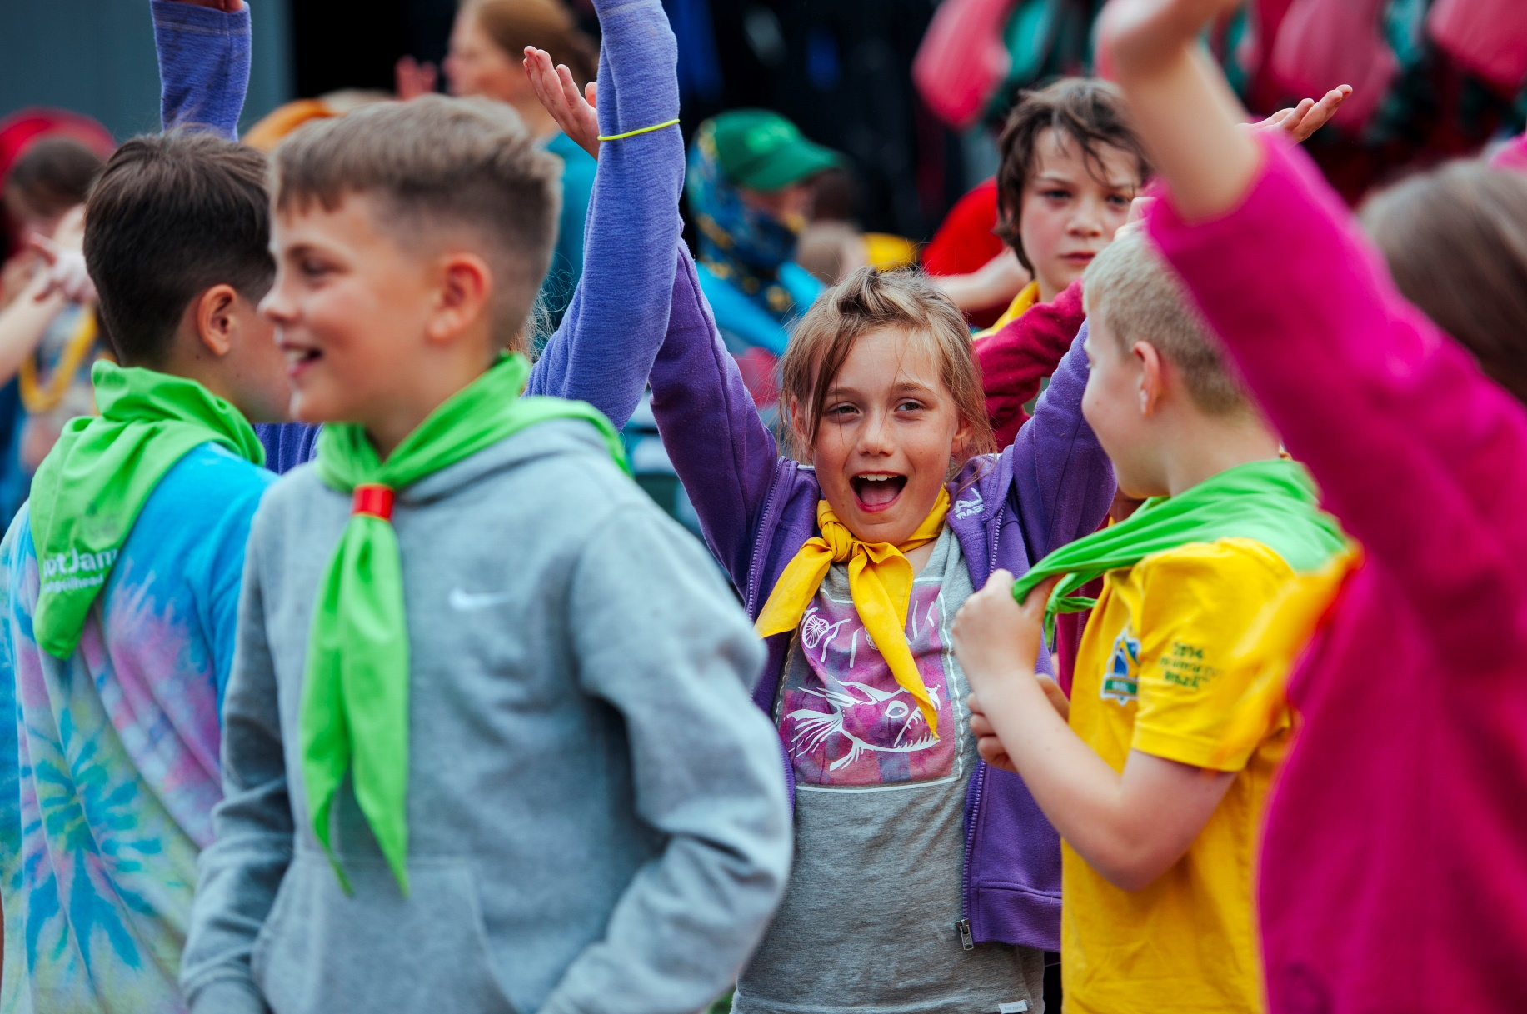

**Media & External Engagement Lead**

**Job Pack**



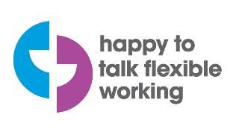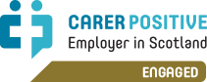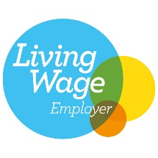

# Welcome

As Scouts, we believe in empowering young people with skills for life. We encourage our young people to do more, learn more and be more.

We question and listen and form wide open minds. We take a deep breath and speak up. We think on our feet. See the big picture. Ignore the butterflies and go for it.  
  
We get back up and try again. We think about what’s next, and plan for it. We jump in, get muddy, give back and get set.  
  
We’re Scouts and everyone’s welcome here. All genders, races and backgrounds. Every week we give almost 40,000 6-25 year olds across Scotland the skills they need for school, college, university, the job interview, the important speech, the tricky challenge and the big dreams: the skills they need for life.

We make a big difference. You could too.

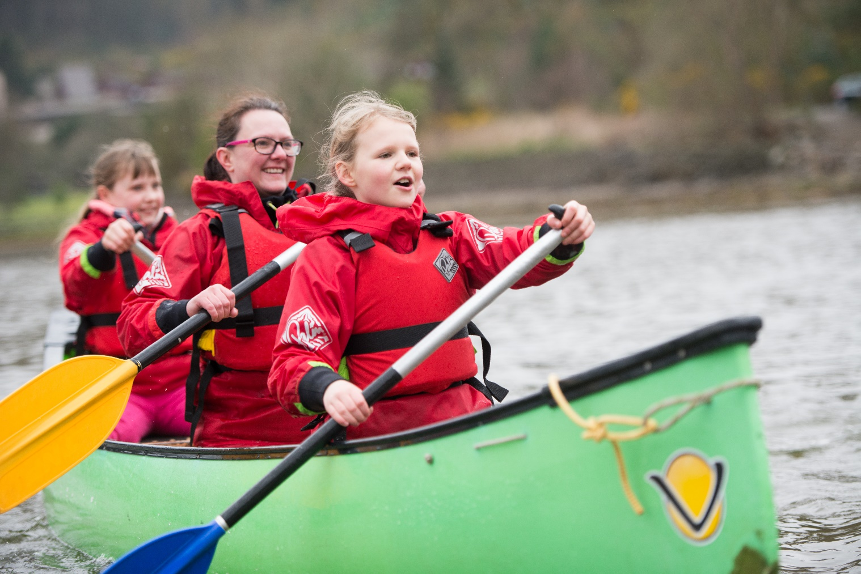

**Our values**

* **Integrity**
* **Respect**

## Care

## Belief

## Cooperation

**Skills for Life**

Our plan to prepare better futures in Scotland 2018-2023

|  |  |  |  |  |
| --- | --- | --- | --- | --- |
| Our vision  By 2023 we will have prepared more young people We will be growing, more inclusive, shaped by with skills for life, supported by amazing leaders young people and making a bigger impact in delivering an inspiring programme. our communities. | | | | |
| Our mission  Scouting actively engages and supports young people in their personal development, empowering them to make a positive contribution to society. | | Our values  We act with care, respect, integrity, cooperation,  exploring our own and others’ beliefs. | | |
| Our goals  By delivering this plan we will achieve the following goals against our four objectives: | | | | |
| Growth | Inclusivity | | Youth Shaped | Community Impact |

* 5,000 more young people
* 1,000 more Section Leaders (including Assistant Section Leaders)
* 200 new Sections
* 500 more Young Leaders
* Scouting membership reflects society in Scotland, especially, but not exclusively, in areas of deprivation, remote and rural areas and in new communities
  + Young people shaping their Scouting experience, with 50% of Groups and 75% of Districts and Regions earning Youth Approved Awards
  + 50% of youth members taking part in community impact project
  + 50% of young people achieving top awards.

**Our three pillars of work**

To support the Movement to achieve these objectives, we will focus on three pillars of work

Programme

People

Perception

A fun, enjoyable, high quality programme consistently delivered and supported by simple tools.

Scouting will be delivered to more young people from different backgrounds by more, well trained, better supported, motivated adult volunteers from different backgrounds.

[www.scouts.scot/skillsforlife](http://www.scouts.scot/skillsforlife)

Scouting is understood, more visible, trusted, respected and widely seen as playing a key role in society today.

# The role

**Responsible to:** Media & External Engagement Lead

**Department**: Communications & Fundraising

**Salary: Salary**: £30,000 – 34,000

**Hours:** 35 per week. We’re happy to talk flexible working.

**Internal Relationships:** Comms & Fundraising Team, Senior Leadership Team, Scouting Operations Team, Outdoor & Adventure Team, Scottish volunteer teams, local communications volunteers, Scouts Scotland members, parents, and staff at Scouts UK

**External Relationships:** Media, partners, external bodies, agencies and networks, membership across all levels in Scotland, existing and potential customers / users of our Centres, general public.

**PVG:** Basic. Wherever we go and whatever we do, we put young people’s safety and wellbeing first.

**At a glance**

We’re looking for someone who really knows their stuff on all things media and external engagement to join our fun and friendly comms & fundraising team.

This is an exciting role that makes a big difference. You’ll be shaping and delivering our media and engagement work, which means looking after our proactive and reactive press, supporting our fantastic community impact work, and helping us to engage meaningfully with partners, elected officials, and decision makers.

We have a really fun and inspiring brand to work with, which is all about skills for life. Every day you’ll be helping us to get that message out into the world so more young people can join in and achieve incredible things with Scouts.

If you’re creative, enthusiastic, full of ideas for promoting Scouts, really good at writing, and have a track record of delivering great media and public affairs work, then we’d love to hear from you!

# Key tasks

# Summary

* Lead on media and external engagement activity to support the Scouts Scotland Strategy.
* Raise positive awareness of Scouts in the media, among influential decision makers, leaders of civic Scotland, politicians and others in key public positions, members of Scouts Scotland and the general public.
* Keep up to date on public policy, and Scottish parliamentary affairs, identifying and responding to opportunities for Scouts Scotland to meaningfully engage.

# Support our community impact work to promote projects and work across Scotland, building strategic relationships with external organisations to help our members make a difference in their communities.

# Provide media and engagement training, advice and support for our staff, volunteers and young people.

# 

# Key tasks

* Responsibility for responding to media enquiries and delivering media announcements, producing succinct and accurate content to deadline for a range of media channels.
* Act as a media spokesperson for Scouts Scotland, providing critical capacity to support communications in unpredictable and sometimes serious situations than can require 24/7 support.
* Work with the Head of Communications & Fundraising to lead the planning and management of pro-active external communications to support the delivery of the Scouts Scotland strategy, informing and engaging external stakeholders.
* Build positive relationships with producers and editors of Scotland-wide media channels and with journalists reporting on youth issues, education and third sector policy and practice.
* Monitor media activity and measure our impact in delivering key Scouts Scotland messaging.
* Develop and implement the public affairs strategy and plan, focusing on relationship-building, policy engagement, advocacy and opinion influencing on issues of concern and interest to Scouts Scotland.
* Implement a contact strategy for Scottish Parliamentarians, liaising as appropriate with our UK headquarters colleagues to implement similar protocols with respect to Westminster.
* Maintain and update the lobbying register with relevant interactions with MSPs
* Provide research and briefing on key issues as required and contribute to the development of position papers and responses to relevant consultations and policy reports.
* Work with the lead volunteer for Community Impact to support and promote community impact projects and work across Scotland.
* Build and maintain strategic relationships with external organisations to help our members make a difference in their communities.
* Provide training, advice, and support to develop the skills and practice of local volunteers, including development young spokespersons, to support effective local PR and media activities and local stakeholder engagement.
* Build a network of Scout media volunteers across Scotland to facilitate engagement with local media and the building of an up to date image library to support on-brand media activity.
* Contribute to projects relating to marketing and the perception of Scouts.
* Represent Scouts Scotland at relevant external conferences and events.
* Undertake any other reasonable and related tasks allocated by your line manager.

# The person we’re looking for

### Skills and Abilities

* Excellent copywriting and editing skills.
* Great communicator who can adjust communication style to different audiences.
* Understanding of different audiences and how to reach them.
* Friendly and enjoy working with lots of people from different backgrounds and experiences.
* Build and maintain relationships with people at all levels and of all ages.
* Creative and ideas driven.
* Work to deadlines and pay attention to detail.
* Prioritise work load in a busy environment.
* Excellent attention to detail and completion, making sure quality and consistency is maintained at all times.
* Flexibility in approach to work and willingness to learn.
* Comfortable with public speaking and giving presentations.

### Knowledge and Experience

* At least 2 years experience of working in a media and engagement role in which influencing and building relationships with external audiences was key to your role.
* Experience of developing and delivering high impact influencing strategies/campaigns.
* Experience of servicing the internal public affairs needs of an organization (briefings, parliamentary monitoring, speeches, etc.)
* Experience of policy development (including research, consultation and development of proposals) on the basis of internal and external agendas.
* Experience of basic events management (e.g. receptions/launches, Parliamentary Receptions, etc)
* Experience of researching and analysing Information.
* Show excellent public speaking skills.
* Demonstrate a clear writing style (e.g. reports, briefing papers, letters).
* Understanding of GDPR and best practice for all data protection and permissions.
* Understanding and awareness of the charity sector (desirable).

### Values and Personal Qualities

* + Enthusiastic and proactive team player.
  + Willingness to work some unsociable hours, including evenings and weekends.
  + Embrace of the purpose and values of The Scouts.

.

**Summary Terms and Conditions**

|  |  |
| --- | --- |
| **Title:** | **Media & External Engagement Lead** |
|  |  |
| **Salary:**  **Pension:** | £30,000 – 34,000 depending on experience  A contributory pension scheme is available. Contribution rates are 7% of salary from the employer and a minimum of 5% from the employee. |
| **Hours of work:** | 35 hours per week. We’re happy to talk flexible working. |
| **Location:**  **Holiday:**  **Extra holidays:**  **Benefits** | Hybrid working from home and our office in Dunfermline.  22 days a year, rising by 1 day per year of service to a maximum of 27 days, plus 9 bank holidays.  We close during the Christmas and New Year holidays, which means you get 3 days of extra leave.  We offer a wide range of family and carer friendly benefits to support work life balance including, but not limited to flexible hours, paid leave for volunteering and public duties, additional leave for long service. |

Scouts Scotland is a registered Scottish Charity No. SC017511