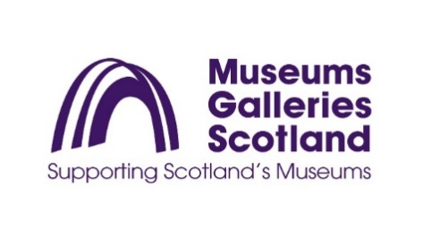

**EQUAL OPPORTUNITIES MONITORING FORM**

Museums Galleries Scotland (MGS) has an equal opportunities policy. MGS is monitoring details of applicants' sex, ethnic origin, marital status, age and disability so that we can ensure that our recruitment is fair and does not discriminate against any group. We would be grateful therefore if you would complete this form.

The information provided in the monitoring form is not used in the selection process. It is used purely to monitor the effectiveness of MGS’s Equal Opportunities Policy.

**The selection and interview panels do not see the information contained in these monitoring forms.**

**Where did you hear about this vacancy?**

|  |
| --- |
|  |

**Age**

|  |
| --- |
|  |

**Gender**

|  |  |  |  |  |  |  |  |  |  |
| --- | --- | --- | --- | --- | --- | --- | --- | --- | --- |
| Female |  | Intersex |  | Male |  | Non-binary |  | Prefer not to say |  |

**Are you married or in a civil partnership?**

|  |  |  |  |  |  |  |
| --- | --- | --- | --- | --- | --- | --- |
| No |  | Yes |  |  | Prefer not to say |  |

**Sexual orientation**

|  |  |  |  |  |  |  |  |  |  |
| --- | --- | --- | --- | --- | --- | --- | --- | --- | --- |
| Bisexual |  | Gay |  | Heterosexual |  | Lesbian |  | Other |  |
| Prefer not to say |  |  |

**What is your ethnicity?**

Ethnic origin is not about nationality, place of birth or citizenship. It is about the group to which you perceive you belong. Please select the appropriate group.

*Asian/Asian British*

Indian  Pakistani  Bangladeshi  Chinese  Prefer not to say

Any other Asian background, please write in:

*Black/ African/ Caribbean/ Black British*

African  Caribbean  Prefer not to say

Any other Black/African/Caribbean background, please write in:

*Mixed/multiple ethnic groups*

White and Black Caribbean  White and Black African  White and Asian

Prefer not to say  Any other mixed background, please write in:

*White*

English  Welsh  Scottish  Northern Irish  Irish

British  Gypsy or Irish Traveller  Prefer not to say

Any other white background, please write in:

*Other ethnic group*

Arab  Prefer not to say  Any other ethnic group, please write in:



We welcome applications from people with disabilities and will make reasonable adjustments necessary for candidates to participate on equal terms in the recruitment process and fulfil the duties of the post if selected.

Museums Galleries Scotland would be grateful if you could provide the following information. You do not have to disclose any disability, but if you do, you will be protected under the terms of the Equality Act 2010 and will allow Museums Galleries Scotland to make any reasonable adjustments necessary to the recruitment process and to provide any auxiliary aids or support necessary for you to fulfil the duties of the role.

**Do you consider yourself to be a disabled person under the terms of the Equality Act (2010)?**

|  |  |  |  |  |  |  |
| --- | --- | --- | --- | --- | --- | --- |
| **Yes** |  | **No** |  |  | **Prefer not to say** |  |

**If yes, what is the nature of your disability?**

|  |
| --- |
|  |

**Do you have any disability-related access requirements? (e.g. adjustments to enable you to attend interview whether online or in person, information in an alternative format or other adjustments?)**

|  |
| --- |
|  |