**Disability Equality Scotland**

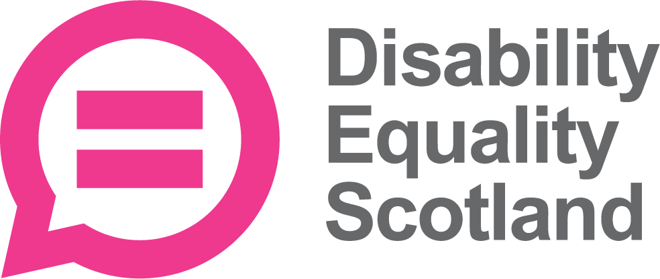

**Equality Form**

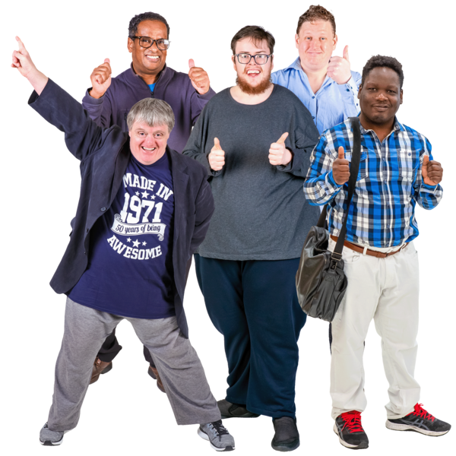

**Easy Read**

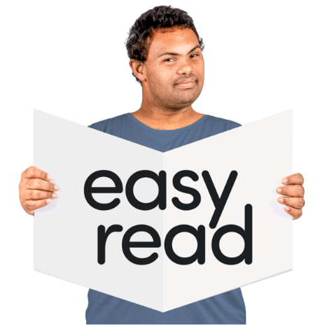

Copyright images © Photosymbols. Prepared by Disability Equality Scotland 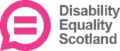

|  |  |  |
| --- | --- | --- |
| A woman pointing at herself to indicate 'me' | Disability Equality Scotland want to ask some questions about you.  It helps us check if everyone has the chance to get a job with us. | |
| a woman with her fingers to her lips and the word 'confidential' in front of her. | Your information is private.  We will not share your information with anyone else. | |
| black cross on a red circle | You don’t have to answer any of the questions if don’t want to. | |
| **Tick the box of the answer you agree with and a tick will appear.**  If you change your mind you can click on it again to untick it. | | |
| **Disability** | | |
| **Do you have a physical or mental health condition or illness that is lasting a year or more?**  Tick 1 box. | | |
| A woman who is a wheelchair user pointing upwards to indicate 'me' | | **Tick Yes**Yes  Cross No No  **?** I don’t know |
| **Does it affect you in any of these ways?**  Tick as many boxes as you need to. | | |
| an earEye | | Sight (for example blindness or partial sight)    Hearing (for example deafness or partial hearing) |
| a man thinkinga woman with a think bubble above her head, thinking of memories.Hands a woman climbing stairs | | Moving around (for example walking short distances or climbing stairs)  Using your hands (for example lifting or carrying objects, using a keyboard)  Learning, understanding or concentrating  Remembering things |
| black cross on a red circleA pile of calendar pages showing years 2023, 2024 and 2025. A red arrow points away to show further years.a stressed woman holding her head.a girl with an asthma inhalera brain inside an outline of a head | | Mental health  A long-term illness (such as diabetes, cancer, HIV, heart disease or epilepsy)  Breathing, tiredness or being able to do physical things for more than a short time.  Affecting the way you behave, or how you cope in social situations (for example autism, attention deficit disorder or Asperger’s syndrome)  Other – please write it here:  None of the above. |
| **How would you describe your gender?**  Tick the box that best describes you. | | |
| gender symbol.  A black silhouette with the letter 'M' and a black silhouette with the letter 'F' | | Female  Male  Non binary  Another way to describe me .  I don’t want to say |
| **How would you describe your sexual orientation?**  Sexual orientation means what kinds of people you love or have sexual or romantic feelings about.  Tick the box that best describes you. | | |
| a man and a woman holding hands. | | Heterosexual or Straight.  This is where you are attracted to a person of the opposite gender. |
| a man with his arms around a woman and a man | | Bi or bisexual. This is where you are attracted to both men and women. |
| Two men with their arms round each other. | | Gay or lesbian. This is where you are attracted to a person of the same gender. |
| black cross on a red circle | | I don’t want to tell you. |
| a woman thinking | | I would describe it in another way. |
| a man opening a birthday card, next to a birthday cake. | | **How old are you?**  **Tell us your age on your last birthday.**  **Write it here:** |
| Group of people from different ethnic groups | | **How would you describe your ethnicity?**  Ethnicity is the word we use to describe our background**.**  People from an ethnic group might have the same language, culture or religion.  Tick the box that best describes you. |
| **White** | | |
|  | English  Welsh  Scottish  Northern Irish  Irish  British  Gypsy or Traveller  I don’t want to say  Other White background | |
| **Mixed or multiple ethnic groups:** | | |
|  | White and Black Caribbean  White and Black African  White and Black Asian  I don’t want to say  Any other mixed ethnic background. Please write it here: | |
| **Asian, Asian Scottish or Asian British** | | |
|  | Pakistani, Pakistani Scottish or Pakistani British  Bangladeshi, Bangladeshi Scottish or Bangladeshi British  Indian, Indian Scottish or Indian British  Chinese, Chinese Scottish or Chinese British  I don’t want to say  Other Asian background. Please write it here: | |
| **Black, African, Caribbean and Black British** | | |
|  | African  Caribbean  I don’t want to say  Other, please write it here: | |
| **Other ethnic group** | | |
|  | Arab  I don’t want to say  Other ethnic background  Please write it here: | |
| **Do you have a religion?**  A religion is a set of beliefs that some people have. There are many different religions, each with a different set of beliefs. Tick 1 box that describes your beliefs.  a religious symbol.a religious symbol.a religious symbol.a religious symbol. | | |
|  | | No religion  Christian – Church of Scotland  Christian – Roman Catholic  Christian – Other denomination  Muslim  Buddhist  Sikh  Jewish  Hindu  Pagan  I don’t want to say  Other - please write it here: |
| email on a computer screen. | Please save your answers.  Send this form with your application to:  [recruitment@disabilityequality.scot](mailto:people@alliance-scotland.org.uk)  Lyn Pornaro  Chief Executive Officer  Disability Equality Scotland | |

Copyright images © Photosymbols. Prepared by Disability Equality Scotland 