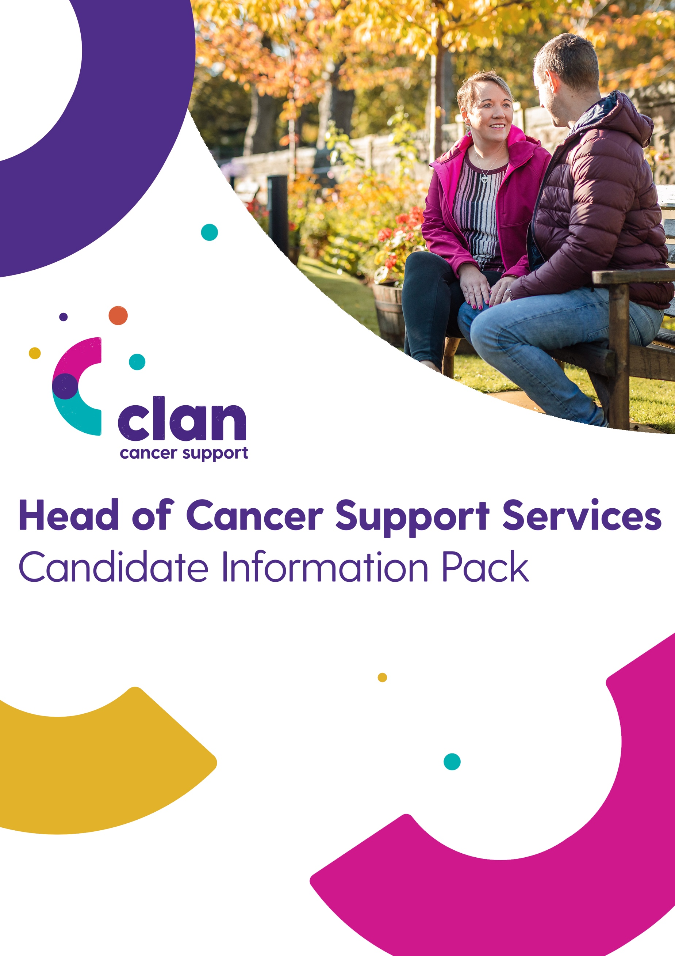

Head of Income Generation and Business Development

Contact:
Catriona Mackie
Director
0141 212 7555
cmackie@aspenpeople.co.uk

Contents
About Clan Cancer Support 3
Mission, Vision & Values 4
CLAN mission statement: 4
CLAN's vision: 4
CLAN values: 4
Our Services Include: 5
Advert 6
Head of Income Genereration and Business Development 6
Job Description and Person Specification 8
Head of Income Generation and Business Development 8
Background to Appointment: 8
Key Accountabilities: 9
Candidate Profile: 10
Remuneration Package: 12
How to Apply 13
Enquiries 13
Timetable 13

About Clan Cancer Support
CLAN Cancer Support is a well-established local charity providing emotional and practical support to people affected by cancer across north-east Scotland, Moray, Orkney and Shetland. We offer a relaxed, welcoming and caring environment both at CLAN House, our purpose-built support and wellbeing centre in Aberdeen, and at our many bases in the community.
Over the last 38 years CLAN has developed specialist knowledge and understanding of how a diagnosis of cancer impacts not just the person diagnosed but also their wider circle of family and close friends. Our range of person centred services, delivered using qualified and experienced counsellors and therapists and support volunteers focused on the general wellbeing of our clients.
Services available include information and support, counselling, complementary therapies, social and wellbeing activities and dedicated support for children and families. For those travelling to Aberdeen hospitals for appointments or treatment, we also offer affordable B&B accommodation at CLAN Haven alongside assistance with transport to and from hospital.
CLAN aims to help people live with and beyond cancer and improve the quality of life for all those who turn to us for help and support. We rely on the generosity of so many individuals, families and companies to ensure the ongoing provision of our free services. More detailed information on our services and fundraising activities can be found on the relevant pages of our website or you can contact any of our local centres.

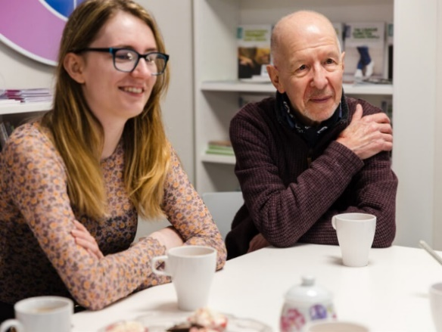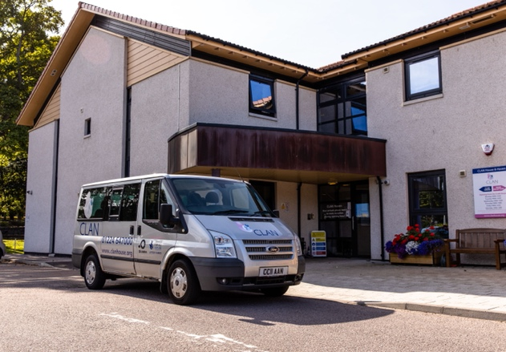

Mission, Vision & Values

CLAN mission statement:
To provide person-centred, community based, professional cancer support services free of charge to anyone with any type of cancer and their families and friends, throughout the north-east of Scotland and the Northern Isles.

CLAN vision:
To be a centre of excellence for the delivery of practical, emotional and social support for people affected by cancer in the north-east of Scotland and the Northern Isles recognised for our professionalism, outreach to and support for communities and as a great place to work.

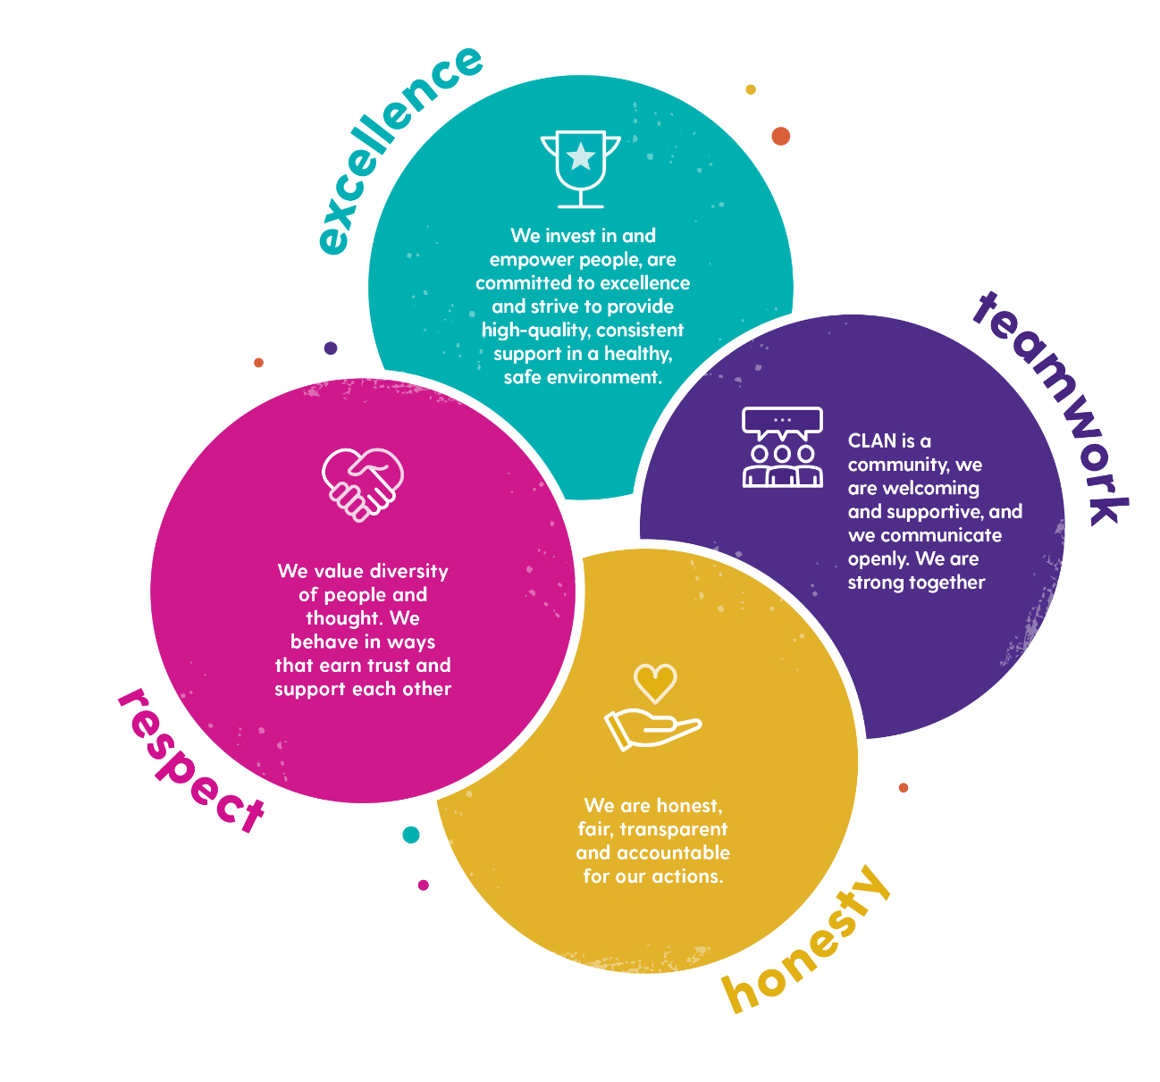
CLAN values:

Our Services Include:
о 11 CLAN wellbeing and support centres and outreach bases in the heart of local communities across north-east Scotland, Moray, Orkney and Shetland.
о Vital wellbeing support, practical support and information.
о Complementary therapies aimed at reducing the pain and stress and anxiety that can accompany a cancer diagnosis.
о Emotional support and professional counselling and social and wellbeing activities throughout our CLAN in the Community network.
о A home-from-home at CLAN Haven in Aberdeen. 27 ensuite bedrooms providing purpose-designed bed and breakfast accommodation for cancer patients and carers travelling to Aberdeen for treatment.
о A dedicated, trained and confidential support team for children, young people and families. CLAN’s Children & Families Service works with individuals or family units to support positive family communication, build resilience and support children.
о A telephone support service to ensure that people affected by cancer can get the support they need regardless of where they are.

Advert

Head of Income Generation and Business Development
Competitive salary plus benefits
Aberdeen
Clan Cancer Support is a well-established and highly regarded, local charity providing emotional and practical support to people affected by cancer, their family, carers and friends. Services are freely offered to all from pre-diagnosis and diagnosis through treatment and beyond at 11 support and wellbeing centres located across north-east Scotland, Moray, Orkney and Shetland. The charity’s aim is to help people live with and beyond their or their loved one’s cancer diagnosis and improve the quality of life for all those who turn to the charity for help and support. For so many, cancer is no longer life ending, but it will forever be life changing. The charity has grown considerably over the last few years and this talented team has continuously responded successfully to the financial requirements of this ambitious charity in an increasingly challenging external environment.
The Head of Income Generation and Business Development will be tasked with capitalising on the opportunities presented by Clan’s current income streams whilst developing and future proofing sustainable, more commercial areas for income generation. A key element of the role will be to further develop and mentor the talented and committed income generation team to reach their full potential. You will also work closely with the Chief Executive as part of the senior management team, to deliver the charity’s strategic objectives.
The successful candidate will be highly credible leader with proven experience gained in business development possessing a successful track record of developing compelling commercial strategies that deliver increased revenues. Ideally, you will already be well networked at appropriate levels within the North-East business community and display the presence and maturity to win the confidence of this community and high net worth individuals. Previous retail and/or hospitality experience would be advantageous given the opportunity for the charity to further develop revenue in these sectors.
This opportunity exists to make a real impact on an already established, successful and respected charity. In return the appointee will be rewarded by having made a tangible and meaningful contribution to the lives of people affected by cancer, their family, carers and friends.
For a confidential discussion about the opportunity, please contact Catriona Mackie or Kate Kennedy at our recruitment partners, Aspen People, on 0141 212 7555.
Closing date for applications: Monday 7th March 2022
You will find the full Job Description and Person Specification within this pack.

Job Description and Person Specification

Head of Income Gernation and Business Development

Clan Cancer Support is a well-established and highly regarded, local charity providing emotional and practical support to people affected by cancer, their family, carers and friends. Services are freely offered to all from pre-diagnosis and diagnosis through treatment and beyond at 11 support and wellbeing centres located across north-east Scotland, Moray, Orkney and Shetland.

The charity’s aim is to help people live with and beyond their or their loved one’s cancer diagnosis and improve the quality of life for all those who turn to the charity for help and support. For so many, cancer is no longer life ending, but it will forever be life changing.

The organisation has a staff of 60 comprising full-time and part-time employees and contracted staff, supplemented by a significant community of committed and talented volunteers. The service delivery team operates a range of support services extending from the Clan Haven and other support services delivered from the base in Aberdeen, to the hub and spoke infrastructure present in our communities and aimed at providing support wherever it is most needed.

Effective income generation allows Clan to deliver its essential support services and the organisation has an established and successful income generation team. The charity has grown considerably over the last few years and this talented team has continuously responded successfully to the financial requirements of this ambitious charity in an increasingly challenging external environment.

Background to Appointment:
Covid has changed the fundraising landscape completely and Clan has continuously responded to these demands through the innovation and development of digital and sustainable income streams.
Commitment to a diverse fundraising mix focused on trusts, legacies, major donors, events, corporate engagement, community fundraising and the network of Clan shops across the region, has ensured the charity’s success despite a very challenging external environment. Each element makes a meaningful and significant contribution to meeting the annual costs associated with the delivery of our vital support services.
The appointee will be tasked with capitalising on the opportunities presented by Clan’s current income streams whilst developing and future proofing sustainable, more commercial areas for income generation.
A key element of the role will be to further develop and mentor the talented and committed income generation team to reach their full potential. This must be achieved in a supportive and positive manner aligned to the values of the organisation and our ethos of OneClan.
This opportunity exists to make a real impact on the income generation efforts of this already established, successful and respected charity. In return the appointee will be rewarded by having made a tangible and meaningful contribution to the lives of Clan’s clients.

Key Accountabilities:
- Work closely with the Chief Executive as part of the senior management team, to deliver the charity’s strategic objectives through the provision of a structured income generation and business development strategy that optimises the organisation’s fundraising capabilities.

- Assume direct responsibility for the development of the annual budget and subsequent implementation of the operational plans to achieve and exceed annual income targets.

- Develop productive and commercially advantageous external relationships with target companies and high net worth individuals, ensuring that Clan is positioned strategically, commercially and operationally to deliver on the expectation of these external partners.

- Lead, support and mentor key team members to enhance Clan’s fundraising, community fundraising, events, trusts, legacies and major donor work. Ensure clear strategies for development are in place for each income stream and that individuals feel the encouragement and autonomy to excel in their roles.

- Assess the organisation’s retail strategy to develop a retail culture that optimises the current offering and continues the growth of this key contributor to the charity’s identity and income efforts.

- Work closely with the Chief Executive and other appropriate team members to identify and execute new commercial opportunities that ensure a transition to stable and sustainable income streams.

- Build and maintain excellent relationships internally, working closely with colleagues across the organisation to ensure the ongoing cohesion between income generation and Clan’s service delivery teams.

- Help to strengthen the visibility and profile of the organisation across its geographic footprint, working with the marketing team to ensure a continuous stream of proactive and engaging social media, PR and marketing campaigns, in line with annual income generation plans.

- OneClan - make a significant contribution to the further development of a positive, values-driven, supportive and team-orientated culture within the income generation and business development team,

- Leverage the full capabilities of the Clan Board in support of income generation and business development efforts and keep the Board regularly informed and advised of all factors relevant to income strategies.

- Adopt a transparent and “no surprises” approach to reporting and communication with the Chief Executive whilst being prepared to challenge the norm in a constructive and proactive manner.

Candidate Profile:

Highly credible with proven experience gained in business development and ideally charitable fundraising, possessing a successful track record of developing compelling commercial strategies that deliver increased revenues.

Well organised, relationship builder with strong interpersonal and negotiating skills, outstanding commercial awareness and good all round business acumen. Must display the presence and maturity to influence and win the confidence of the business community and high net worth individuals.

Ideally, already well networked at appropriate levels within the North-East business community, professionally respected and possess the capability to leverage personal credibility and networks to Clan’s advantage.

Accustomed to working in a business development environment with long lead times from building a relationship to generating donations, therefore must possess the skills to nurture relationships and influence potential funders both tactically and strategically.

Previous retail and/or hospitality experience would be advantageous given the opportunity for the charity to further develop revenue in these sectors.

Attuned to developing unilateral support, co-operation and team-spirit across an organisation in order to ensure fundraising initiatives are aligned with the service delivery needs of the organisation.

A motivator possessing an engaging and positive personality, with a real understanding of the value and importance of team spirit in an environment where alignment to the values and purpose of the organisation is paramount.

Resilient character who can demonstrate the highest degree of integrity, honesty and commitment.

Possess energy, commitment, and ultimately the ambition and leadership skills to further develop an already successful income generation team to the next level in market engagement and revenue development.

Remuneration Package:
Reflecting the importance of this key appointment, Clan is prepared to offer a competitive salary and benefits package to attract an ambitious and effective business development professional.

CLAN Cancer Support is a registered charity No. SC022606

How to Apply
To apply for this position please upload a CV and supporting statement at the following link:
CLAN Cancer Support – Head of Income Generation & Business Development
If you have any queries about the application process, please contact Kelsey Bettoli on 0141 212 7555.

Enquiries
For a confidential discussion about the role please contact Catriona Mackie or Kate Kennedy at Aspen People, on 0141 212 7555.

Timetable
Closing date: Mondy 7th March 2022
Interviews: TBC

Contact

Catriona Mackie
Director
0141 212 7555
cmackie@aspenpeople.co.uk

