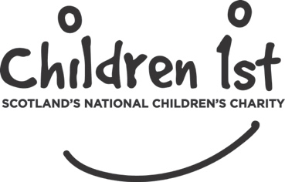

Charities and Trustee Investment (Scotland) Act 2005
DECLARATION

In addition to adhering to the Bye-Laws relating to the Board of Management set out in the Children 1st, Royal Scottish Society for Prevention of Cruelty to Children, Royal Charter, under section 69 of the Charities and Trustee Investment (Scotland) Act 2005, certain persons are unable to be elected to the post of Trustee. These are:

- Anyone convicted of an offence involving dishonesty or an offence under the Act, which conviction is not spent by virtue of the Rehabilitation of Offenders Act 1974

- An undischarged bankrupt

- Anyone removed from serving as a charity trustee or from being in management or control of a charity under the Law Reform (Miscellaneous Provision) Scotland Act 1990; by the Charity Commission for England and Wales; or by the English Courts

- A person disqualified from serving as a company director

Disqualification is automatic under the Act and acting whilst disqualified is an offence which carries penalties.

If you consider that any of these may apply to you please discuss with Aspen People who will seek further clarification if necessary.

I declare that I know of no reason why I cannot be elected to the post of Trustee.

I declare that I have read OSCR’s Guidance for Charity Trustees publication.

Signature:………………………………………… Date:……………………………

