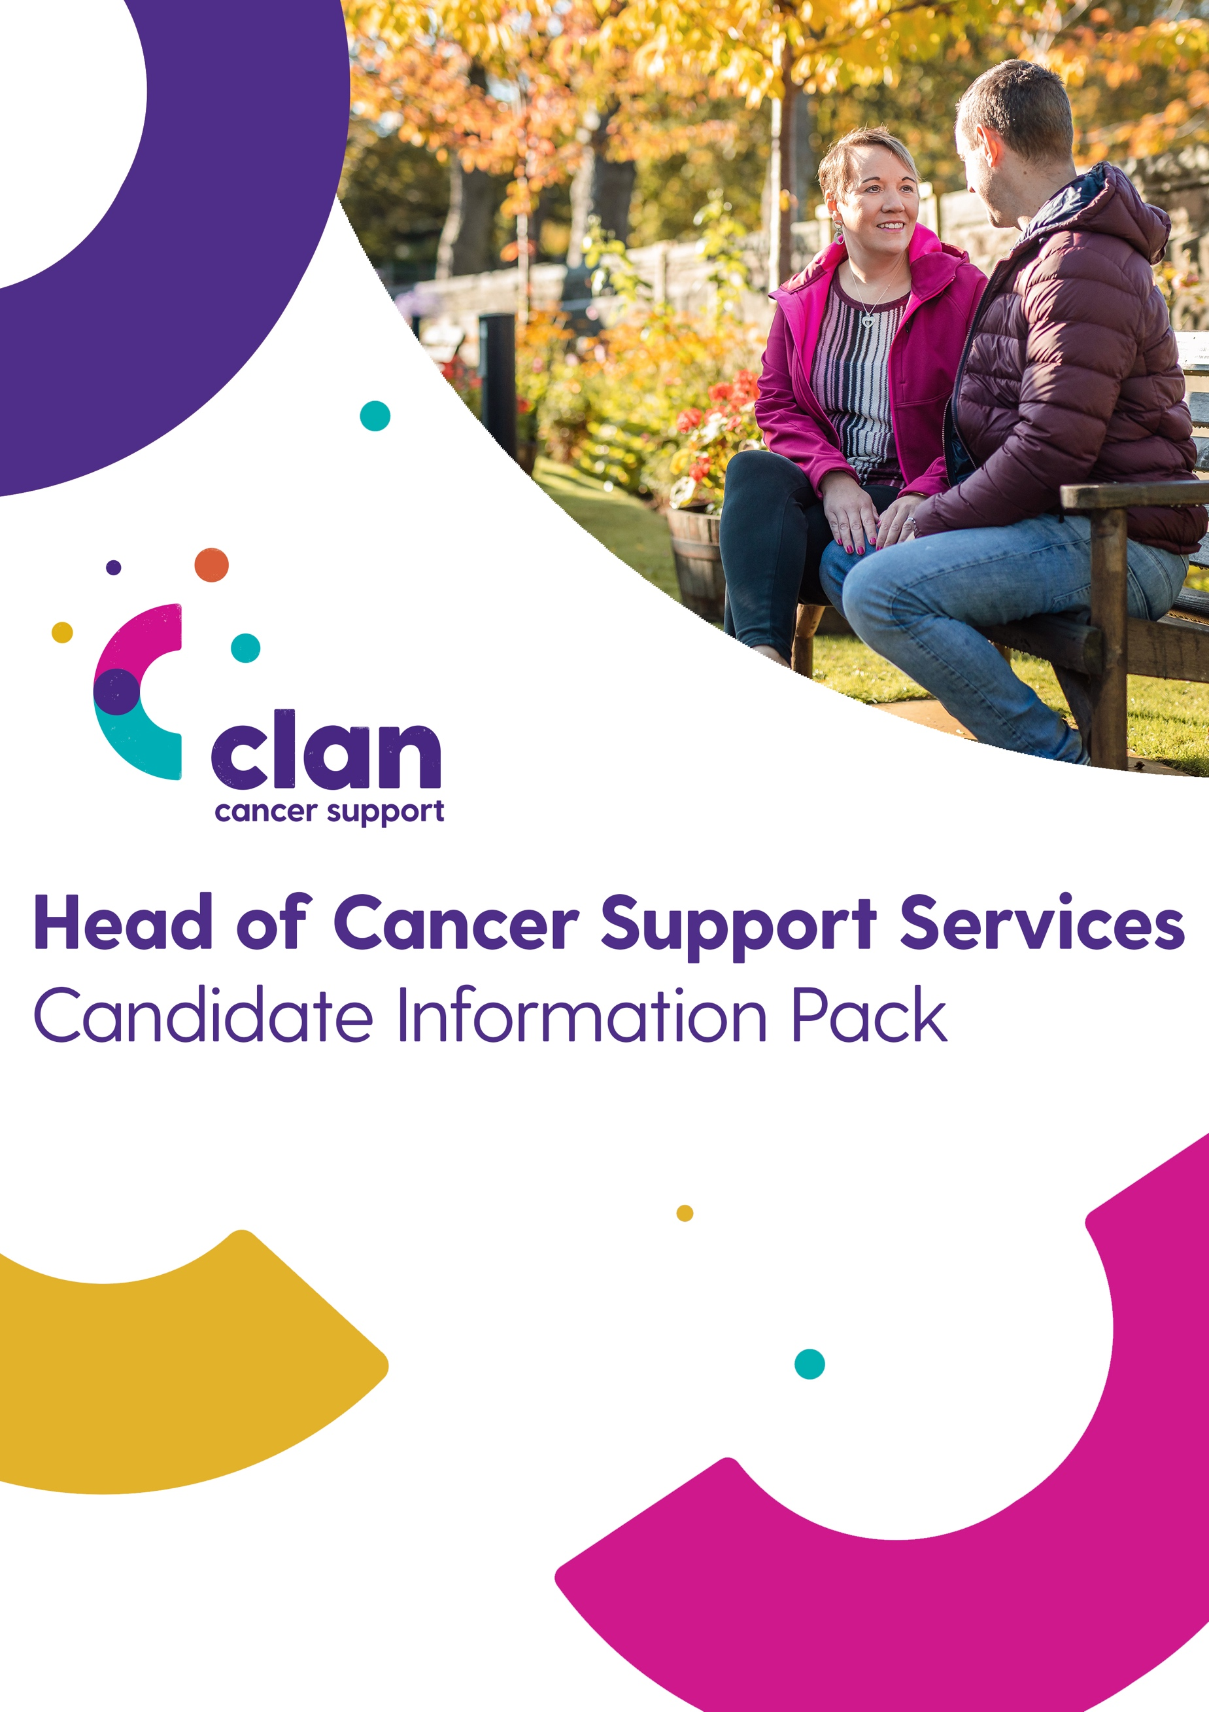

Contact:
Catriona Mackie
Director
0141 212 7555
cmackie@aspenpeople.co.uk

Contents
About Clan Cancer Support 3
Mission, Vision & Values 4
CLAN mission statement: 4
CLAN's vision: 4
CLAN values: 4
Our Services Include: 5
Advert 6
Head of Cancer Support Services CLAN Cancer Support 6
Job Description and Person Specification 7
Head of Cancer Support Services 7
Background to Appointment: 7
Key Accountabilities: 8
Candidate Profile: 9
Remuneration Package: 10
How to Apply 11
Enquiries 11
Timetable 11

About Clan Cancer Support
CLAN Cancer Support is a well-established local charity providing emotional and practical support to people affected by cancer across north-east Scotland, Moray, Orkney and Shetland. We offer a relaxed, welcoming and caring environment both at CLAN House, our purpose-built support and wellbeing centre in Aberdeen, and at our many bases in the community.
Over the last 38 years CLAN has developed specialist knowledge and understanding of how a diagnosis of cancer impacts not just the person diagnosed but also their wider circle of family and close friends. Our range of person centred services, delivered using qualified and experienced counsellors and therapists and support volunteers focused on the general wellbeing of our clients.
Services available include information and support, counselling, complementary therapies, social and wellbeing activities and dedicated support for children and families. For those travelling to Aberdeen hospitals for appointments or treatment, we also offer affordable B&B accommodation at CLAN Haven alongside assistance with transport to and from hospital.
CLAN aims to help people live with and beyond cancer and improve the quality of life for all those who turn to us for help and support. We rely on the generosity of so many individuals, families and companies to ensure the ongoing provision of our free services. More detailed information on our services and fundraising activities can be found on the relevant pages of our website or you can contact any of our local centres.

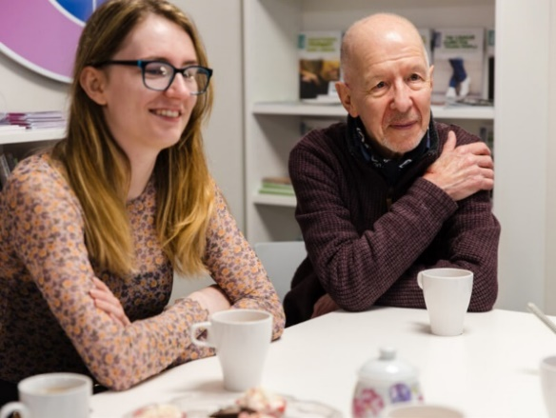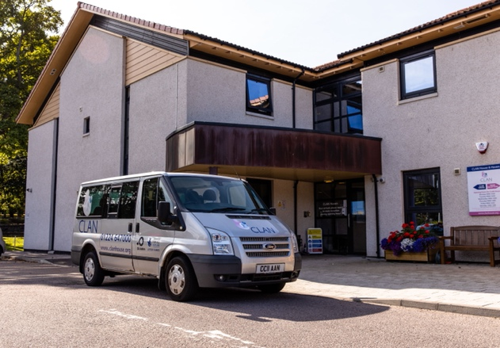

Mission, Vision & Values

CLAN mission statement:
To provide person-centred, community based, professional cancer support services free of charge to anyone with any type of cancer and their families and friends, throughout the north-east of Scotland and the Northern Isles.

CLAN vision:
To be a centre of excellence for the delivery of practical, emotional and social support for people affected by cancer in the north-east of Scotland and the Northern Isles recognised for our professionalism, outreach to and support for communities and as a great place to work.

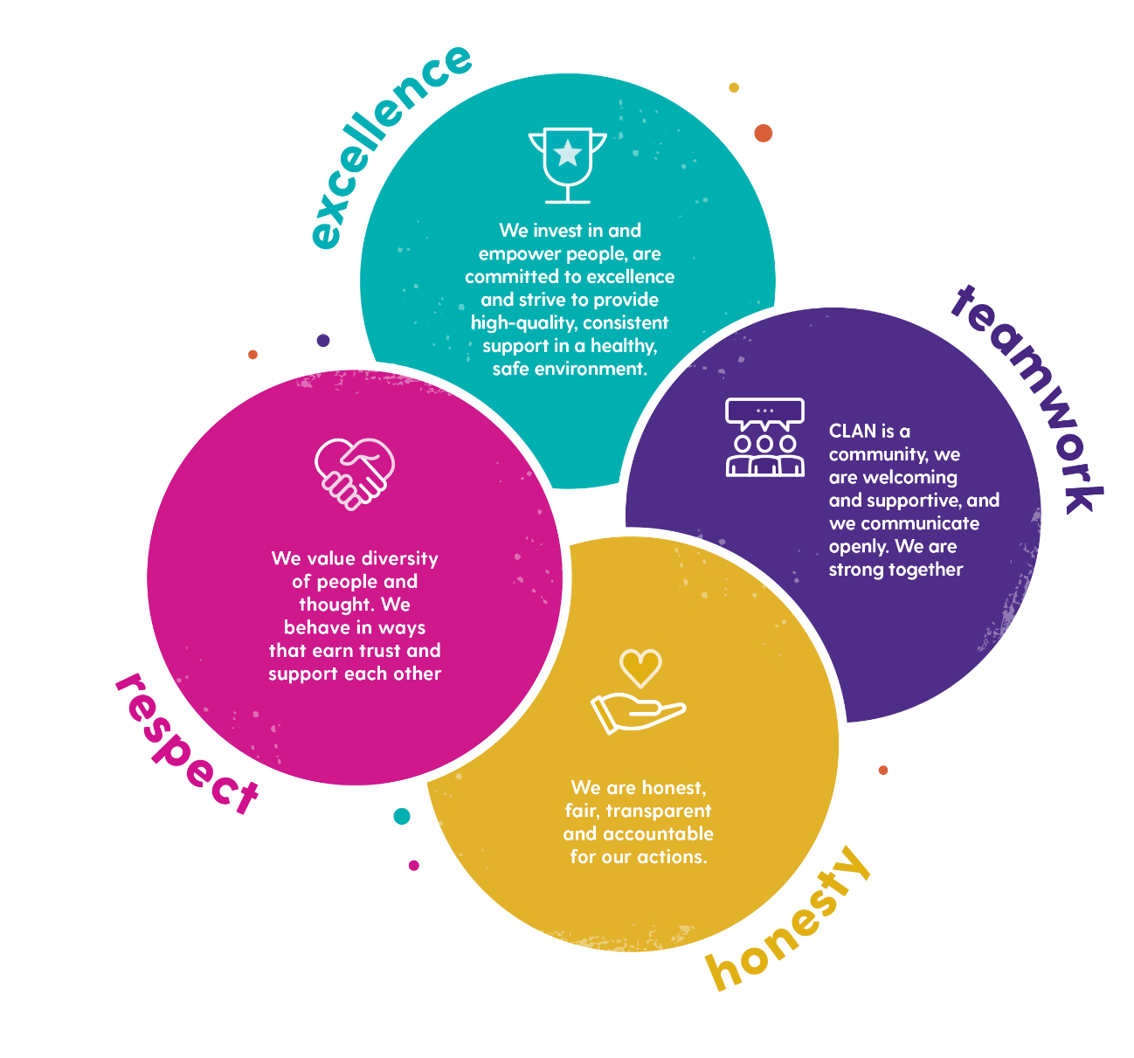
CLAN values:

Our Services Include:
о 11 CLAN wellbeing and support centres and outreach bases in the heart of local communities across north-east Scotland, Moray, Orkney and Shetland.
о Vital wellbeing support, practical support and information.
о Complementary therapies aimed at reducing the pain and stress and anxiety that can accompany a cancer diagnosis.
о Emotional support and professional counselling and social and wellbeing activities throughout our CLAN in the Community network.
о A home-from-home at CLAN Haven in Aberdeen. 27 ensuite bedrooms providing purpose-designed bed and breakfast accommodation for cancer patients and carers travelling to Aberdeen for treatment.
о A dedicated, trained and confidential support team for children, young people and families. CLAN’s Children & Families Service works with individuals or family units to support positive family communication, build resilience and support children.
о A telephone support service to ensure that people affected by cancer can get the support they need regardless of where they are.

Advert

Head of Cancer Support Services CLAN Cancer Support
We are seeking a collaborative and driven Head of Cancer Support Services to join the senior management team and lead CLAN’s programme of integrated support to people affected by cancer into a new and exciting era.
The appointee will build and maintain excellent collaborative relationships with the NHS, health and social care partnerships, and other key stakeholders across CLAN’s geographic reach in the north of Scotland to assess and determine future cancer support service’s needs, in line with national and local cancer policy and strategic planning.
Leading a multi-disciplined team of experienced practitioners, the appointee will build on CLAN’s established Support Services experience and the unique opportunities presented by creating new ways of remote and digital working developed during the COVID-19 pandemic, to develop an integrated, robust and forward-looking Support Services programme.
The appointee will be responsible for ensuring that this programme is provided in accordance with CLAN’s policies and procedures, culture, values and brand and that all CLAN’s cancer support centres and outreach services are appropriately resourced and managed in support of the programme and client’s needs.
Reporting to the Chief Executive, the postholder will join the CLAN Board and assume responsibility for keeping Trustees informed and advised of all factors relevant to cancer service delivery.
The successful candidate will be capable of demonstrating proven service delivery experience, ideally in a health and social care environment. Consideration will be given to candidates who feel they have transferable skills from sectors out with traditional health and social care. Importantly, they will possess energy, commitment, ambition and the leadership skills to support and further develop an already successful cancer services team to the next level in service delivery.
In addition to a offering rewarding career and competitive salary, CLAN delivers a range of staff benefits including competitive holiday entitlement, workplace pension and flexible working.
You will find the full Job Description and Person Specification within this pack.

Job Description and Person Specification

Head of Cancer Support Services
CLAN Cancer Support is a well-established, local charity providing emotional and practical support to people affected by cancer, their family, carers and friends. Services are freely offered to all from pre-diagnosis, prehabilitation and diagnosis through treatment and beyond at 11 support and wellbeing centres located across north-east Scotland, Moray, Orkney and Shetland.
The charity’s aim is to help people live with and beyond their or their loved one’s cancer diagnosis and improve the quality of life for all those who turn to the charity for help and support.
The organisation has around 60 full-time and part-time employees and contracted staff, supplemented by a significant community of committed and talented volunteers. The service delivery team operates a range of support services extending from the CLAN Haven and other support services delivered from the base in Aberdeen, to the ‘local’ infrastructure aimed at providing support wherever it is most needed within communities across north east Scotland.
The Cancer Support Services team incorporates the Aberdeen, Aberdeenshire, Moray, Orkney and Shetland Services Teams; Children and Family Support Team; and the Haven Support Worker Team. The charity has grown considerably over the last few years and the Cancer Support Services team has continuously responded successfully to the challenge delivering a wide range of professional cancer support services within a complex and dynamic external environment, particularly during the COVID19 pandemic, and to changes to the health and social care infrastructure.

Background to Appointment:
Following the departure of the current Head of Cancer Support Services, CLAN currently seeks to appoint a health and social care professional with experience of leading people and delivering projects, as Head of Cancer Support Services.
CLAN has established a leading position in cancer support in the region through its work with cancer patients and their families and relationships with the NHS across the north of Scotland and the islands, Aberdeen City and Shire Councils, Voluntary Sector Organisations, and the business community. The appointee will be responsible for the development, review and implementation of CLAN’s cancer support service strategy in line with CLAN’s aims, ethos and strategy, ensuring services remain client focused and offer opportunities to enhance wellbeing throughout a cancer journey.

The role involves some travel throughout the North-east of Scotland, Orkney and Shetland.

Key Accountabilities:
- Work closely with the Chief Executive as part of the senior management team to deliver the charity’s strategic objectives through the provision of a structured cancer support service strategy in line with national and local cancer policy.
- To lead regular engagement opportunities with clients, key stakeholders and partner organisations to assess and determine future service delivery.
- Lead, support and mentor the services teams including Children and Family Services; Haven Support Services; Wellbeing Services and Volunteer Services in Aberdeen, Aberdeenshire, Moray, Orkney and Shetland, to ensure clear strategies for development are in place and that they feel the encouragement and receive support to assume full responsibility for their areas of expertise.
- Make a significant contribution to the further development of a positive, values-driven, supportive and team-orientated culture within the cancer services team.
- To ensure excellent communications across the Services Team so that teams and individuals are equipped to meet agreed objectives that lead to the achievement of the CLAN strategic aims.
- Build and maintain excellent relationships internally, working closely with colleagues to develop and maintain an effective relationship between fundraising and service delivery teams, ensuring that there is reciprocal data sharing needed to secure adequate levels of funding and enhance service provision.
- Strengthen the visibility and profile of the organisation across its geographic footprint, working with the marketing team to ensure a continuous stream of proactive and engaging social media, PR and marketing campaigns.
- To attend CLAN Board and committee meetings and prepare papers for these on behalf of the services team, keeping Trustees regularly informed and advised of all factors relevant to service delivery strategies.
- Adopt a transparent and “no surprises” approach to reporting and communication with the Chief Executive whilst being prepared to challenge in a constructive and proactive manner.
- Ensure adequate supervision and management is in place for all service delivery practitioners including support contractors (Counsellors and Therapists).
- Ensure all policies and procedures adhere to legal requirements particularly in relation to safeguarding, adult and child protection, client confidentiality and data protection.
- Ensure that projects are effectively established and delivered within agreed timescales and identify the core activities and timescales for each activity with effective monitoring and reporting of service delivery statistics.
- Develop the services and project budgets with the finance team and control expenditure through on-going financial monitoring.
- To help reach out to as many potential clients as possible by ensuring our services reflect need; cultural and language issues; challenges such as accessing services due to rurality; transport and costs.
- Raise the profile of CLAN through networking, participating and presenting at conferences/workshops. Establish and maintain effective networks with professional colleagues ensuring that the profile of CLAN’s role in partnership and development is appropriately represented.

Candidate Profile:
- Highly credible with proven service delivery experience gained in a senior management/leadership role in health and social care, ideally with knowledge of or experience in the voluntary sector, possessing a successful track record of developing and implementing services.
- Well organised, relationship builder with strong interpersonal and leadership skills.
- Must display the presence and maturity to influence and win the confidence of the health and social care community and cancer patients and their families.
- Ideally already well networked at appropriate levels within the North-East health and social care community, professionally respected and possess the capability to leverage personal credibility and networks to CLAN’s advantage.
- A motivator possessing an engaging and positive personality, with a real understanding of the value and importance of team spirit in an environment where alignment to the values and purpose of the organisation is paramount.
- Resilient and robust character who can demonstrate the highest degree of integrity, honesty and commitment.
- Possess energy, commitment, and ultimately the ambition and leadership skills to further develop an already successful cancer services team to the next level in a competitive environment.
- Proven experience in internal/external collaborative working and partnership development.
- Ideally holds sound knowledge of the voluntary sector, understands the needs to put clients at the centre of services while working within budgets and understanding the value and challenges that volunteers bring to an organisation.
- Attuned to developing unilateral support, cooperation and team-spirit across an organisation in order to ensure that all service delivery initiatives are aligned with the service delivery and income generating needs of the organisation.
- Excellent demonstrable communication and presentation skills, with ability to represent CLAN externally.
- Ideally a knowledge of digital service delivery, with ability to build on and develop the range of telephone, online and digital services introduced during the COVID-19 pandemic.

Remuneration Package:
Reflecting the importance of this key appointment, CLAN is prepared to offer a competitive salary and benefits package to attract an ambitious and effective cancer support services professional.

CLAN Cancer Support is a registered charity No. SC022606

How to Apply
To apply for this position please upload a CV and supporting statement at the following link:
CLAN Cancer Support – Head of Cancer Support Services
If you have any queries about the application process, please contact Katy or Kelsey on 0141 212 7555.

Enquiries
For a confidential discussion about the role please contact Catriona Mackie, Director of Aspen People, on 0141 212 7555.

Timetable
Closing date: Friday 19th February 2021
Interviews: It is anticipated that initial interviews for this position will take place week commencing 1st March 2021.

Contact

Catriona Mackie
Director
0141 212 7555
cmackie@aspenpeople.co.uk

